**LAB 14**

**Lab Task. 14.1) Write a program in python to add, subtract, multiply and divide 2 input numbers.**

x=int(input("enter a number:"))

y=int(input("enter a another number:"))

print("X + Y =",x+y)

print("X - Y =",x-y)

print("X * Y =",x*y)

print("X / Y =",x/y)

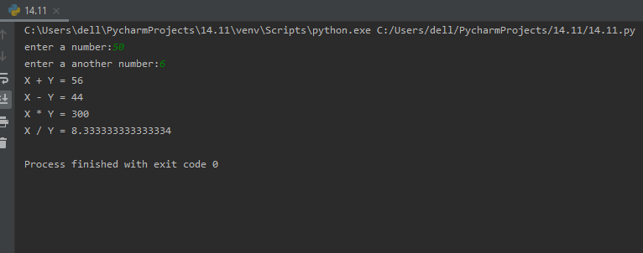

**Lab Task. 14.2) Write a program in python to display a table of input number.**

num = int(input("Enter the number: "))

print("Multiplication Table of", num)

for i in range(1, 11):

print(num,"X",i,"=",num * i)

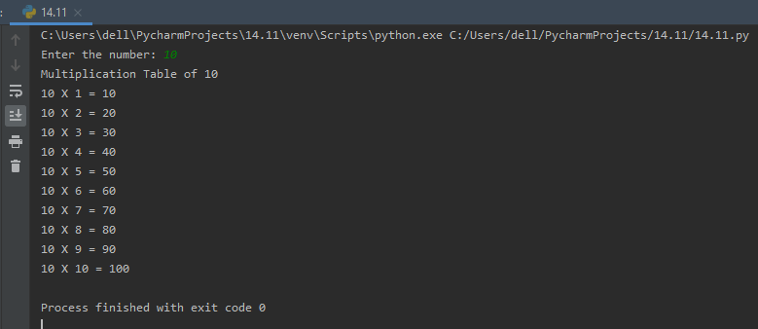

**Lab Task. 14.3) Write a program in python to print odd right-angle triangle.**

num = int(input("Enter the number of rows "))

k=1

for i in range (1, num+1)

for j in range(1,k+1)

print("1", end = "")

k=k+2

print()

